Launch a Web Server Instance
In this lab you will launch a Windows Server 2022 instance with Internet Information Services (IIS) and a Web Page setup.

Sign into the AWS Management Console and open the Amazon EC2 Console . In the upper-right corner of the AWS Management Console, confirm you are in the desired AWS region.

On the left side menu, click on Dashboard under EC2. Then, click on Launch instances.

In Name, type the value [Your Initials] Windows Web Server. Under Application and OS Images (Amazon Machine Image) select Quick Start, then choose Windows. From the Amazon Machine Image (AMI) dropdown menu, choose Microsoft Windows Server 2022 Base

Select t3.medium under Instance Type.

Select the key pair that you created in the beginning of this lab from the drop-down menu.

Under Network Setting, click on Edit.

Set the default VPC and subnet. Then enable the Auto-assign public IP.

Under Firewall (security groups) choose Create security group. Type Immersion Day - Web Server in Security Group name and Description.

For Security group rule 1, leave type as rdp and change Source type to My IP.

Then, select Add Security Group rule.

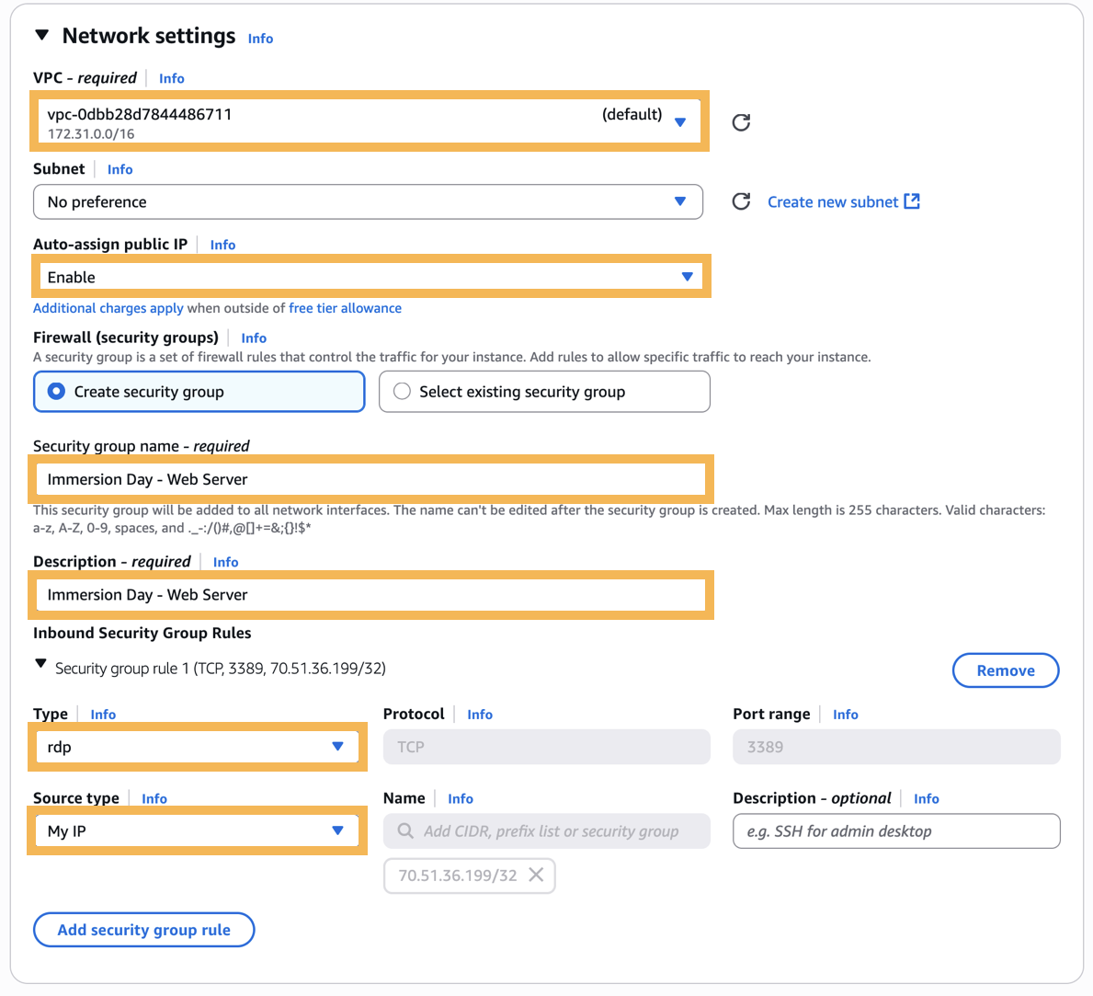

For Security group rule 2, set Type to HTTP and Source type to My IP.

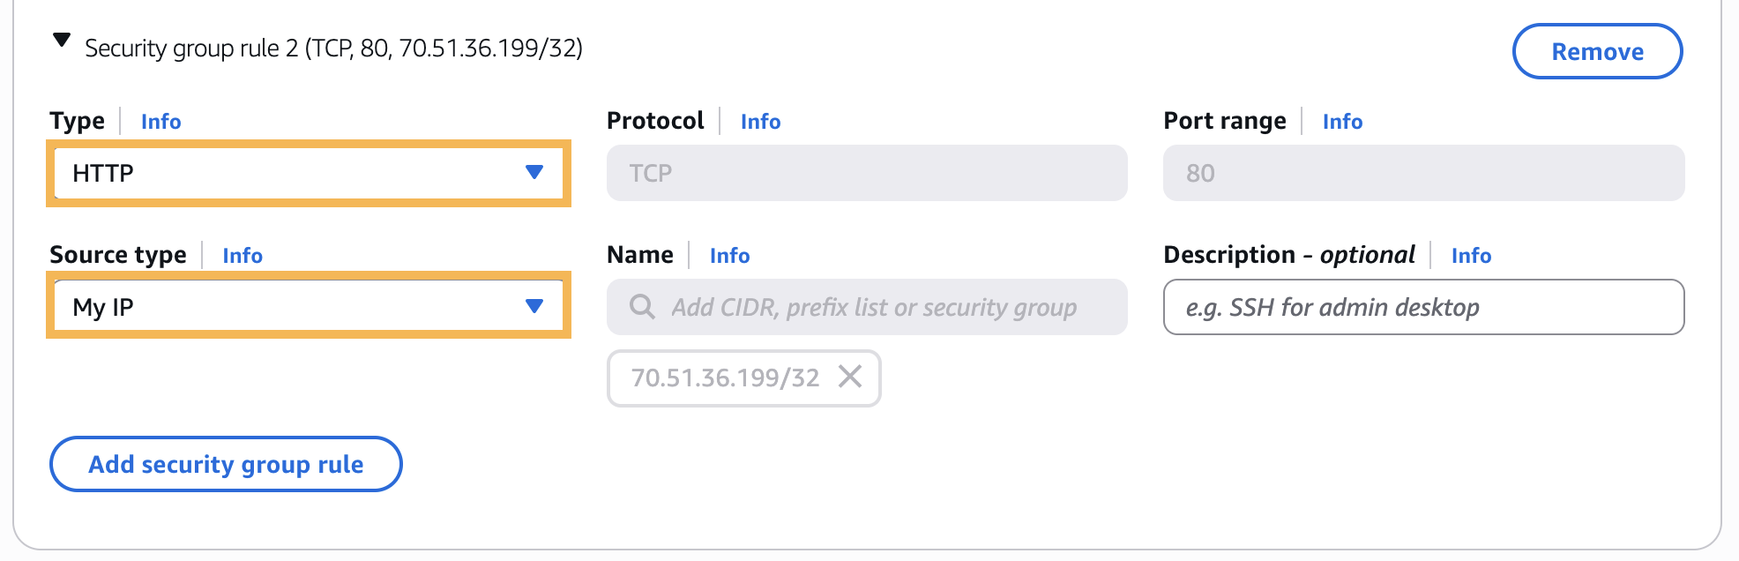

Security groups function as virtual firewalls that control network traffic. Through security group rules, you define which network protocols, ports, and IP addresses are permitted to access your resources, creating a robust first line of defense for your applications and data.

Your Web Server is now accessible from your IP address through two types of network traffic:

RDP (Remote Desktop Protocol) on port 3389, allowing you to connect to and manage your Windows instance.

HTTP on port 80, allowing Internet traffic to reach your instance.

Leave the default values under Configure storage

Expand the Advanced Details. Under Metadata version, select V1 and V2 (token optional).

Under User data copy and paste the following PowerShell script:

Expand the User data section below and copy it by clicking the copy icon in the top-right corner.
User Data
1234567891011121314151617<powershell>Install-WindowsFeature -name Web-Server -IncludeManagementTools$instanceId = (Invoke-WebRequest -Uri http://169.254.169.254/latest/meta-data/instance-id -UseBasicParsing).content$instanceAZ = (Invoke-WebRequest -Uri http://169.254.169.254/latest/meta-data/placement/availability-zone -UseBasicParsing).contentNew-Item -Path C:\inetpub\wwwroot\index.html -ItemType File -ForceAdd-Content -Path C:\inetpub\wwwroot\index.html "<title>Windows EC2 Lab</title>"Add-Content -Path C:\inetpub\wwwroot\index.html "<font face = `"Verdana`" size = `"5`">"Add-Content -Path C:\inetpub\wwwroot\index.html "<center><img src=`"https://d0.awsstatic.com/logos/powered-by-aws.png`" alt=`"Powered by AWS Cloud Computing`"/><center>"Add-Content -Path C:\inetpub\wwwroot\index.html "<center><h1>Windows EC2 Lab</h1></center>"Add-Content -Path C:\inetpub\wwwroot\index.html "<hr>"Add-Content -Path C:\inetpub\wwwroot\index.html "<center> <b>EC2 Instance Metadata</b> </center>"Add-Content -Path C:\inetpub\wwwroot\index.html "<center> <b>Instance ID:</b> $instanceId </center>"Add-Content -Path C:\inetpub\wwwroot\index.html "<center> <b>AWS Availablity Zone:</b> $instanceAZ </center>"Add-Content -Path C:\inetpub\wwwroot\index.html "</font>"</powershell>
If you're interested in learning more about the options under Advanced details, select Info next to it.
- Verify your selections are correct and then choose Launch instance.
- Select View all Instances at the bottom right corner to find the Web Server you just created.
Once your instance has launched, you will see your Web Server as well as the Availability Zone the instance is in, and the publicly routable DNS name.
- Click the checkbox next to your web server to view details about your EC2 instance. Find the Public DNS, you will use this address later on.
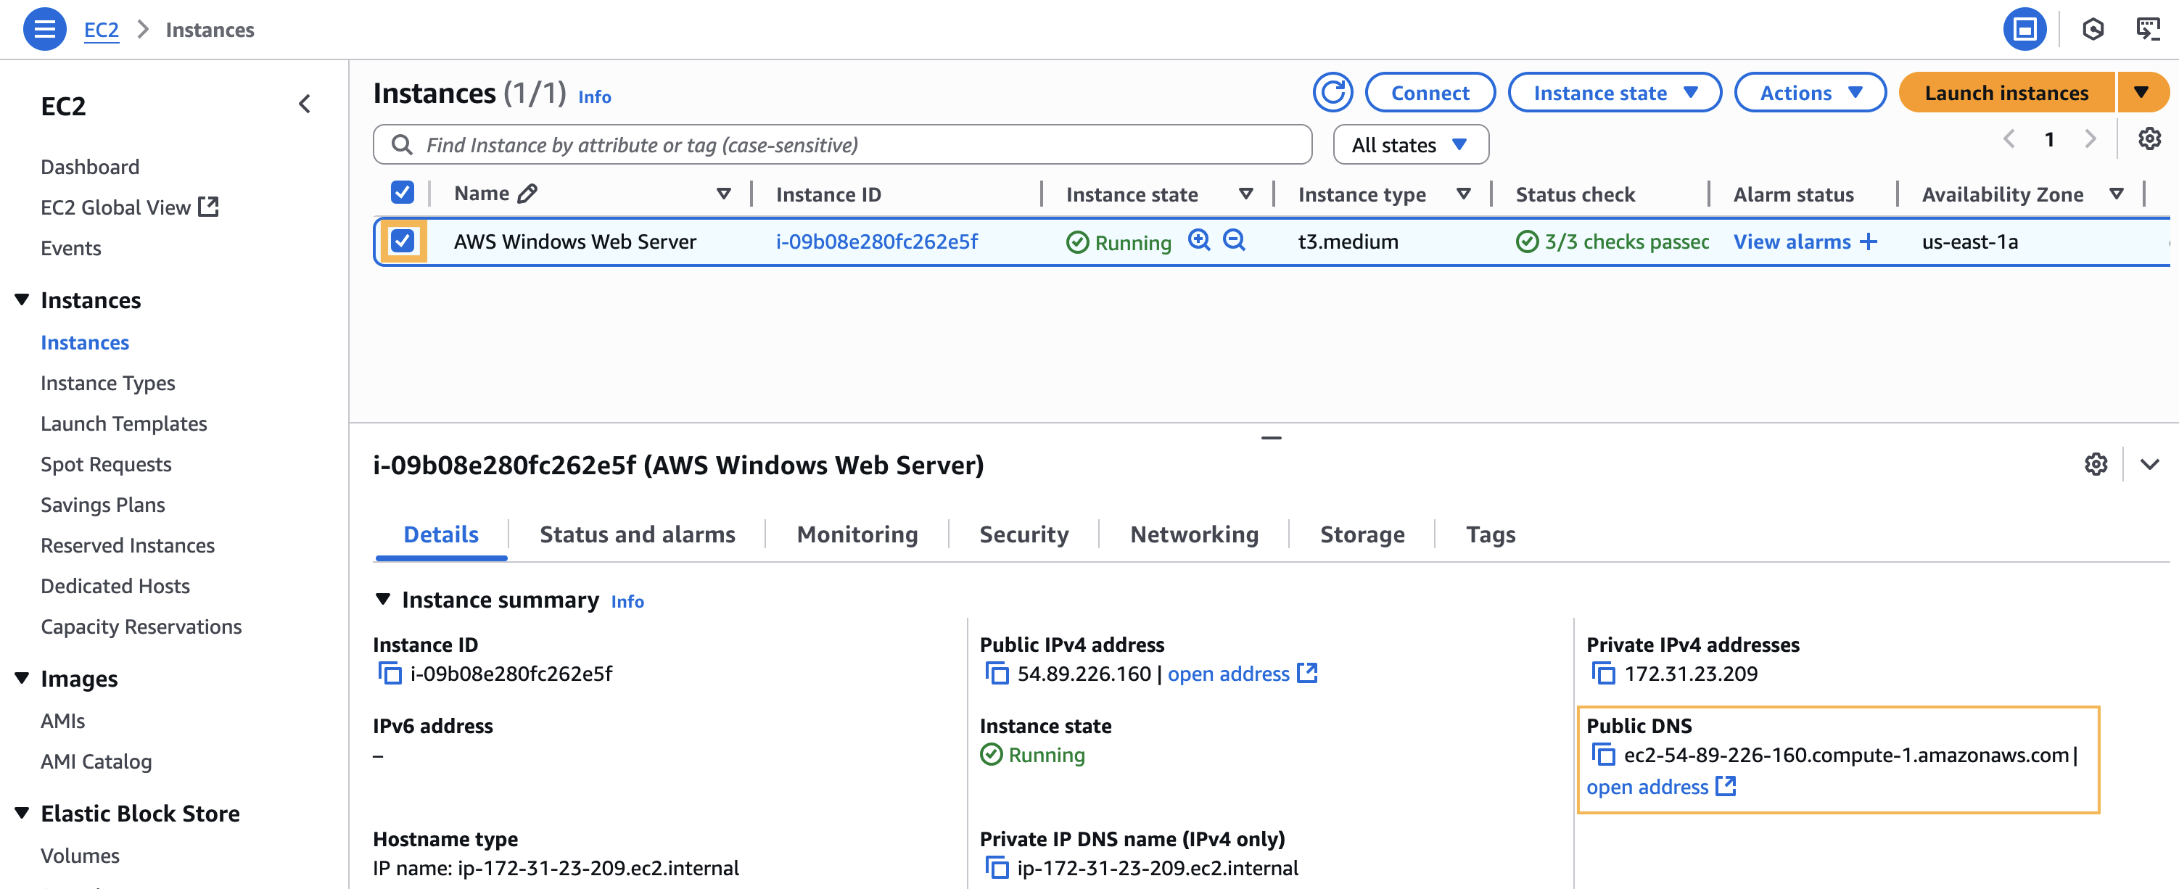

Browse the Web Server

Wait for the instance to pass the Status Checks to finish loading. Open a new browser tab and browse the Web Server by entering your EC2 instance’s Public DNS address.
If you are using the Chrome web browser, when you paste the Public DNS value into the web browser, it might not run if https is automatically added in front of the DNS value. Therefore, it is recommended to enter http://.
You should see a website that looks like the following:
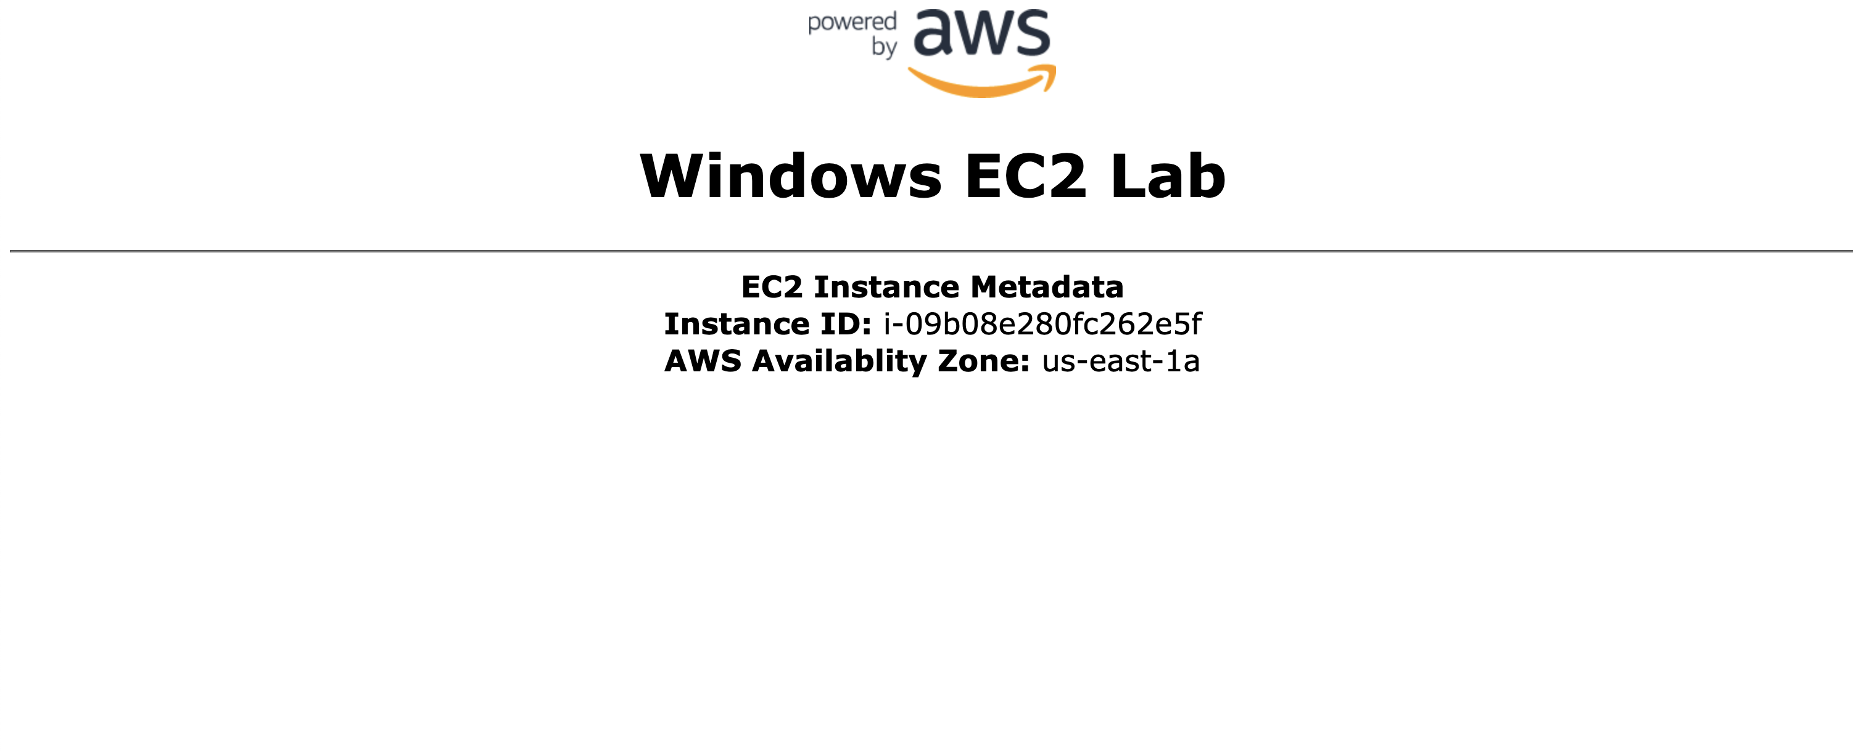
Great Job
You have deployed a server and launched a website!
Please note that IIS installation and configuration may take several minutes to complete. If you open the page and see an error message that the server took too long to respond or if you see the screen shown below then the bootstrap script has not completed. Please wait a few minutes before refreshing the page to try again.

